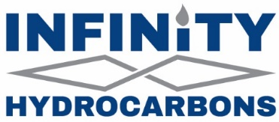
REQUIREMENTS FOR DEATH OF AN INTEREST OWNER
If the decedent died testate (with a will) and the will is being probated the following
must be submitted for our review:
- Copy of the Death Certificate
- Copy of Letters of Testamentary
- Copy of the Will
- Order Admitting the Will to Probate (or its equivalent depending upon the state in which the proceedings were conducted)
- Order Closing the Estate (or its equivalent depending upon the state in which the proceedings were conducted.)
- Documents must be filed of record in the county or counties, where the property or properties are located. Please keep the filed and recorded original for your records. The copy submitted to Opportune must show the recording stamp.
To comply fully with the various state statues, we suggest that you consult an attorney familiar with the laws of the state in which the property is located to see if ancillary probate proceedings are required.
If the decedent died intestate (without a will) or if the will is not being probated the following must be submitted for our review:
- A Certified copy of the Death Certificate
- In the event administration proceedings were necessary, a copy of the Order Appointing Administrator, An Affidavit of Heirship, which must be completed by disinterested party familiar with the facts (not an heir), notarized, and filed of record in the county or counties, where the property or properties are located. Please keep the filed and recorded original for your records. The copy submitted to Opportune must show the recording stamp.
- A copy of the Will (if will is not being probated).

Point of Contact
Infinity Hydrocarbons, LLC
C/O Opportune LP
Attn: Division Orders
10777 Clay Road, Suite 100
Houston, Texas 77041
✉ royalty@opportune.com
(713) 772-0734

